BIG DATA LAB

Name:S.L.A.Laisha

USN:1NT19IS147

SEC:C1

Date: 05-04-2022

To create collection:

>db.createCollection(“Details”)

Update one ($unset)

>db.Details.updateOne({Name:”Rani”},{$unset{“gender”:””}})

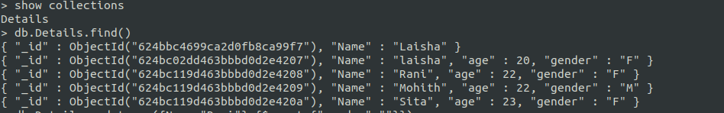

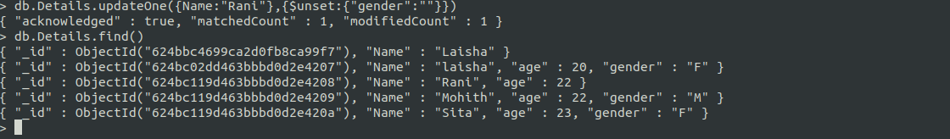

Update many ($unset)

>db.Details.updateOne({Name:Mohith”},{$unset{“Name”:” “,”age”:” “,“gender”:””}})

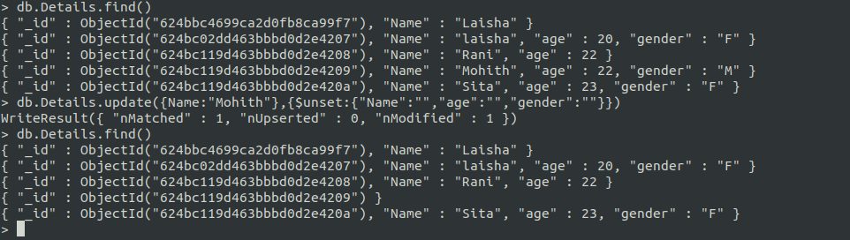

Delete one

>db.Details.deleteOne({Name:”Laisha”})

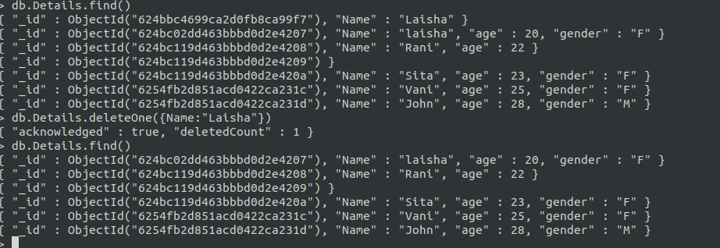

Deleting id when all values are deleted

>db.Details.remove({“_id” : ObjectId(“624bc119d463bbbd0d2e4209)});

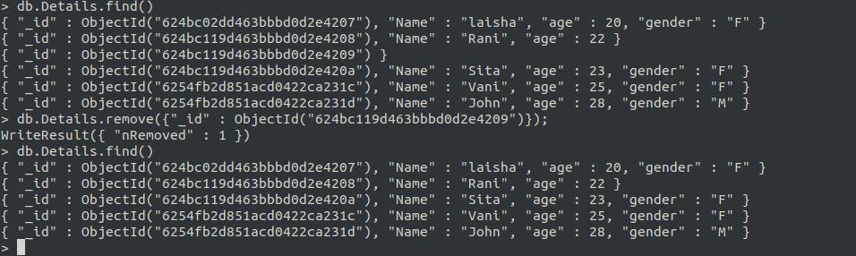

Replace the values (replace one)

>db.Details.replaceOne({Name:"Sita"},{Name:"Snehitha"})

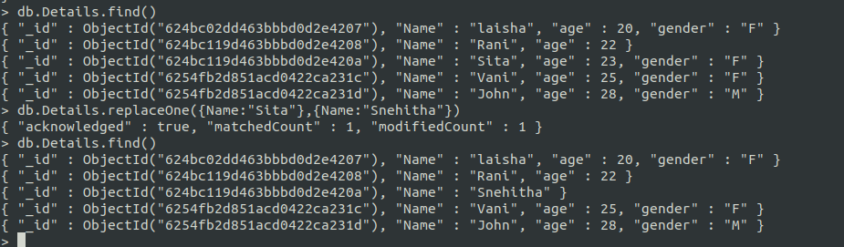

Using AND operator to display details of people with age greater 22 than and gender :Female

>db.Details.find({$and:[{age:{$gte:22}},{gender:"F"}]}).pretty();

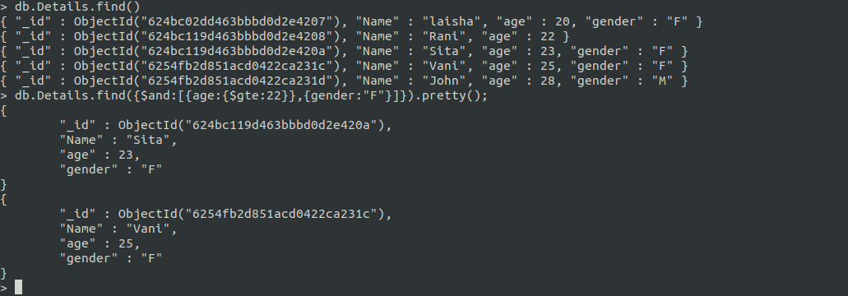

Using OR operator to display details of people with age greater 22 than and gender :Female

>db.Details.find({$or:[{age:{$gte:22}},{gender:"F"}]}).pretty();

